5. Labels, Text Boxes, Variables


Review and Preview

We continue our look at the Visual Basic Express environment and learn some new controls and new BASIC statements. As you work through this class, remember the three steps for building a Visual Basic Express project: (1) place controls on form, (2) assign properties to controls, and (3) write event procedures. In this class, you will examine how to find and eliminate errors in your projects, learn about the label and text box controls, and about BASIC variables. You will build a project that helps you plan your savings.

Debugging a Visual Basic Express Project

No matter how well you plan your project and no matter how careful you are in implementing your ideas in the controls and event procedures, you will make mistakes. Errors, or what computer programmers call bugs, do creep into your project. You, as a programmer, need to have a strategy for finding and eliminating those bugs. The process of eliminating bugs in a project is called debugging. Unfortunately, there are not a lot of hard, fast rules for finding bugs in a program. Each programmer has his or her own way of attacking bugs. You will develop your ways. We can come up with some general strategies, though, and that’s what we’ll give you here.

Project errors, or bugs, can be divided into three types:

- Syntax errors
- Run-time errors
- Logic errors

Syntax errors occur when you make an error setting a property in design mode or when typing a line of BASIC code. Something is misspelled or something is left out that needs to be there. Your project won’t run if there are any syntax errors. Run-time errors occur when you try to run your project. It will stop abruptly because something has happened beyond its control. Logic errors are the toughest to find. Your project will run OK, but the results it gives are not what you expected. Let’s examine each error type and address possible debugging methods.
Syntax Errors

Syntax errors are the easiest to identify and eliminate. The Visual Basic Express program is a big help in finding syntax errors. Syntax errors will most likely occur as you’re setting properties for the controls or writing BASIC code for event procedures.

Start a new project in Visual Basic Express. Go to the project window and try to set the form Width property to the word Junk. (Click the plus sign next to the Size property to see Width.) What happened? You should see a little window like this:

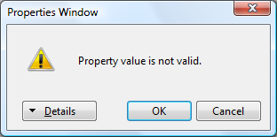

Click Details and you will see an explanation of the problem. Remember that property values must be the proper type. Assigning an improper type to a property is a syntax error. But, we see Visual Basic Express won’t let us make that mistake. Click Cancel to restore the Width to what it was before you tried to change it.

What happens if you cause a syntax error while writing code. Let’s try it. Open the code window for the Form1_Load procedure. Under the header line, type this line, then press <Enter>:

Me.BackColor 0 Color.Red

This would happen if you typed 0 instead of = in the assignment statement. What happened? In the code window, the line will appear underlined with a squiggle, similar to what Microsoft Word does when you misspell a word:

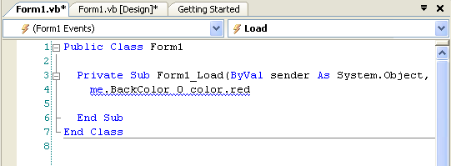

Visual Basic Express has recognized that something is wrong with this statement. You should be able to see what. Any line with an error will be ‘squiggled.’ Placing the cursor over a squiggled line will give some indication of your error. In this case, it will tell you that you need to assign a value to Me.BackColor.

So, if you make a syntax error, Visual Basic Express will usually know you’ve done something wrong and make you aware of your mistake. The on-line help system is a good resource for debugging your syntax errors. Note that syntax errors usually result because of incorrect typing - another great reason to improve your typing skills, if they need it.
Run-Time Errors

Once you successfully set control properties and write event procedures, eliminating all identified syntax errors, you try to run your project. If the project runs, great! But, many times, your project may stop and tell you it found an error - this is a run-time error. You need to figure out why it stopped and fix the problem. Again, Visual Basic Express and on-line help will usually give you enough information to eliminate run-time errors. Let’s look at examples.

Working with the same example as above, try to run the project with the incorrect line of code. After you click the Start button on the toolbar, the following window should appear:

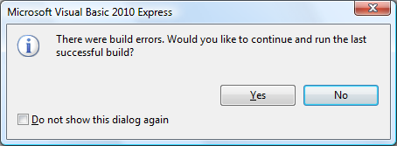

This tell us an error has occurred in trying to ‘build’ the project. Click No – we don’t want to continue. We want to find the error. If ‘build errors’ occur, they are listed in another Visual Basic Express window – the Error List. This list shows you all errors detected in trying to run your program. Go to that window now (if it’s not there already, choose View in menu, select Error List). Error List appears in the Design window. Yours might be floating or docked somewhere.

My Error List window is:

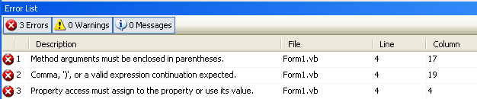

It has three errors that must be cleared before the program will run. Note each task refers to Line 4 on Form1, pointing to the offending line. This is why we number the lines of code in the code window – it makes finding errors much easier. The third error implies we need to assign a value to a property. The other two lines are other ‘guesses’ at what the problem might be. Go to Line 4 in the code window (a quick way to move there is to double-click the error). Line 4 should be highlighted as a ‘bad’ line of code:

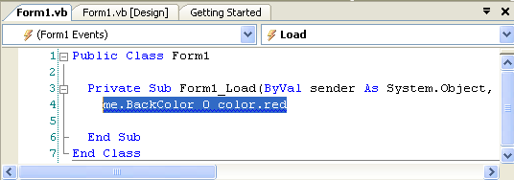

Visual Basic Express is telling you that there is something wrong with how you used this particular line of code. Using the hints from the task list, you should be able to see that the assignment operator (=) is missing. If you don’t see the problem, clicking <F1> might give you more help.

Let’s say we corrected our error by adding the = sign, but we accidentally left out the letter ‘k’ in the BackColor property name, or we typed:

Me.BacColor = Color.Red

Try running the project and you’ll see another ‘build error’ window. Choose not to continue and go to the Error List:

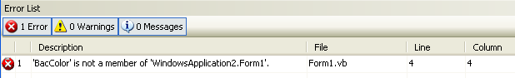

The message again points to Line 4, saying ‘BacColor’ is not a member (property or event) associated with the form. Again, go to Line 4 (double-click the error message) in the code window and you should see:

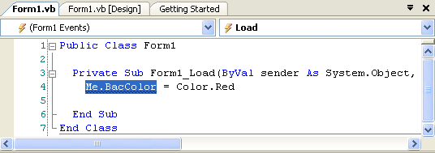
The words Me.BacColor will be highlighted. Visual Basic Express is telling you it can’t find this property for the particular control (the form). You should note the misspelling and correct it.

Now, let’s say you correct the property name, but mess up again and type Mee instead of Me when referring to the form:

Mee.BackColor = Color.Red

Run the project. You will get another build error, choose not to continue and view the Task list:

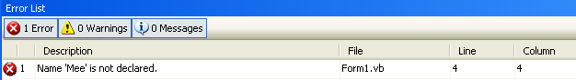

The key message here is ‘Name … is not declared.’ This usually appears when you have misspelled the assigned name of a control in BASIC code. Visual Basic Express is trying to assign a property to something using the ‘dot notation’:

ControlName.PropertyName = Value

But, it can’t find a control with the given name (Mee in this case). Go to the code window, correct the error and run the application. You should finally get a red form!!

The errors we’ve caused here are three of the most common run-time errors: misspelling an assigned Name property, misspelling a property name, or leaving something out of an assignment statement. Notice each run-time error seen was detected prior to running, resulting in a build error. There are other run-time errors that may occur while your application is actually running.
Visual Basic Express refers to some run-time errors as exceptions. If a window appears saying you have some kind of exception, the line with the detected error will be shown with suggestions for fixing the error. Be sure to stop the program before trying to fix the error.

We’ve seen a few typical run-time errors. There are others and you’ll see lots of them as you start building projects. But, you’ve seen that Visual Basic Express is pretty helpful in pointing out where errors are and on-line help is always available to explain them. One last thing about run-time errors. Visual Basic Express will not find all errors at once. It will stop at the first run-time error it encounters. After you fix that error, there may be more. You have to fix run-time errors one at a time.

Logic Errors

Logic errors are the most difficult to find and eliminate. These are errors that don’t keep your project from running, but cause incorrect or unexpected results. The only thing you can do at this point, if you suspect logic errors exist, is to dive into your project (primarily, the event procedures) and make sure everything is coded exactly as you want it. Finding logic errors is a time-consuming art, not a science. There are no general rules for finding logic errors. Each programmer has his or her own particular way of searching for logic errors.

With the example we have been using, a logic error would be setting the form background color to blue, when you expected red. You would then go into the code to see why this is happening. You would see the color Color.Blue instead of the desired value Color.Red. Making the change would eliminate the logic error and the form will be red.

Unfortunately, eliminating logic errors is not as easy as this example. But, there is help. Visual Basic Express has something called a debugger that helps you in the identification of logic errors. Using the debugger, you can print out properties and other values, stop your code wherever and whenever you want, and run your project line-by-line. Use of the debugger is an advanced topic and will not be talked about in this course. If you want to improve your Visual Basic Express skills, you are encouraged to eventually learn how to use the debugger.

Now, let’s improve your skills regarding Visual Basic Express controls. We’ll look at two new controls: the label and the text box.

Label Control

A label is a control that displays information the user cannot edit directly. It is most often used to provide titles for other controls. And, it is used to display the results of some computer operation. The label control is selected from the toolbox. It appears as:

In Toolbox: On Form (default properties):
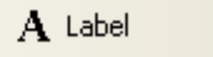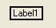

Properties

A few useful properties for the label are:

Property Description
Name Name used to identify label. Three letter prefix for label names is lbl.
Text Text (string type) that appears in the label.
TextAlign Specifies how the label text is positioned.
Font Sets style, size, and type of Text text.
BackColor Sets label background color.
ForeColor Sets color of Text text.
Left Distance from left side of form to left side of label (referred to by X in properties window).
Top Distance from top side of form to top side of label (referred to by Y in properties window).
Width Width of the label in pixels.
Height Height of label in pixels.
BorderStyle Determines type of label border.
Visible Determines whether the label appears on the form (in run mode).
AutoSize If True (default value), label adjusts to size of text. If False, label can be resized.

Note, by default, the label control has no resizing handles. To resize the label, set AutoSize to False.

Example

Make sure Visual Basic Express is running and start a new project. Put a label on the form. Resize it (you need to set AutoSize to False) and move it, if desired. Set the Text property. Try different Fonts. See the difference among the BorderStyle possibilities; notice the default value (None) makes the button match with the form, Fixed Single places a box around the label, and Fixed3D gives the label a three-dimensional inset look. Change the BackColor and ForeColor properties. You may find certain color combinations that don’t do a very good job of displaying the Text when in color. Make sure you are aware of combinations that do and don’t work. You want your user to be able to read what is displayed.

The most used label property is Text. It holds the information that is displayed in the label control. There are two things you need to be aware of. First, by default, the label will ‘grow’ to hold any Text you might provide for it. If the label size is not acceptable, you can try things like changing Font or AutoSize. If the label is made to be larger than the text it holds (by setting AutoSize to False), you will also want to set the TextAlign property. Try different values of the TextAlign property; there are nine different alignments selected from a ‘graphical’ menu:



Vertical choices are: top, middle, and bottom justification. Horizontal choices are: left, center, and right justification.

The second thing you need to know is that Text is a string type property. It can only hold string values. When setting the Text property in run mode, the Text information must be in quotes. For example, if you have a label control named lblExample and you want to set the Text property to My Label Box, you would use the BASIC code (note the dot notation):

lblExample.Text = “My Label Box”

You don’t have to worry about the quotes when setting the Text in design mode. Visual Basic Express knows this is a string value.

Events

There is only one label event of interest:

Event Description
Click Event executed when user clicks on the label with the mouse.

With this event, you could allow your user to choose among a set of displayed label boxes. Why would you want to do this? Example applications include multiple choice answers in a test or color choices.

Typical Use of Label Control

The usual design steps for the label control to display unchanging text (for example, to provide titling information) are:

- Set the Name (though not really necessary since you rarely write code for a label control) and Text property.
- You may also want to change the Font, Backcolor and Forecolor properties.

To use the label control for changing text, for example, to show some computed results, use these steps:

- Set the Name property. Initialize Text to desired string.
- Set AutoSize to False, resize control and select desired value for TextAlign.
- Assign Text property (String type) in code where needed.
- You may also want to change the Font, Backcolor and Forecolor properties.
Text Box Control

The text box control is used to display information entered in design mode, by a user in run mode, or assigned within an event procedure. Just think of a text box as a label whose contents your user can (or may not be able to) change. The text box is selected from the Visual Basic Express toolbox. It appears as:

In Toolbox: On Form (default properties):

Properties

The text box has a wealth of useful properties:

Property Description
Name Name used to identify text box. Three letter prefix for text box names is txt.
Text Text (string value) that appears in text box.
TextAlign Sets whether Text is left-justified, right-justified, or centered in text box.
Font Sets style, size, and type of Text.
MultiLine Specifies whether text box displays one line or multiple lines.
ScrollBars Specifies type of displayed scroll bar(s).
MaxLength Maximum length of displayed Text. If 0, length is unlimited.
BackColor Sets text box background color.
ForeColor Sets color of Text.
Left Distance from left side of form to left side of text box (X in the properties window).
Top Distance from top side of form to top side of text box (Y in the properties window).
Width Width of the text box in pixels.
Height Height of text box in pixels.
ReadOnly If True, user can’t change contents of text box (run mode only).
TabStop If False, the control cannot be ‘tabbed’ to.
BorderStyle Determines type of text box border.
Visible Determines whether the text box appears on the form (in run mode).

Example

Start a new Visual Basic Express project. Put a text box on the form. Resize it and move it, if desired. Set the Text property. Try different Fonts. Try different values of the TextAlign property. See the difference among the BorderStyle possibilities. The label box used None as default, the text box uses Fixed3D. Change the BackColor and ForeColor properties. Set MultiLine to True and try different ScrollBars values. I think you can see the text box is very flexible in how it appears on your form.

Like the Text property of the label control, the Text property of a text box is a string value. So, when setting the Text property in run mode, we must enclose the value in quotes (“) to provide a proper assignment. Setting the Text property in design mode does not require (and you shouldn’t use) quotes.

Events

The most important property of the text box is the Text property. As a programmer, you need to know when this property has changed in order to make use of the new value. There are two events you can use to do this:

Event Description
TextChanged Event executed whenever Text changes.
Leave Event executed when the user leaves the text box and causes an event on another control.

The TextChanged event is executed a lot - every time a user presses a key while typing in the text box, the TextChanged event procedure is called. Looking at the Text property in this event procedure will give you its current value.

The Leave event is the more useful event for examining Text. Remember in placing controls on the form in design mode, you can make one control ‘active’ by clicking on it. There is a similar concept while an application is in run mode. A user can have interaction with only one control at a time. The control the user is interacting with (causing events) is said to have focus. While a user is typing in a text box, that box has focus. The Leave event is executed when you leave the text box and another control gets focus. At that point, we know the user is done typing in the text box and is done changing the Text property. That’s why this event procedure is a good place to find the value of the Text property.

Typical Use of Text Box Control

There are two primary ways to use a text box – as an input control or as a display control. If the text box is used to accept some input from the user, the usual design steps:

- Set the Name property. Initialize Text property to desired string.
- If it is possible to input multiple lines, set MultiLine property to True. Also, set ScrollBars property, if desired.
- You may also want to change the Font, Backcolor and Forecolor properties.

If using the control just to display some information (no user modification possible), follow these usual design steps:

- Set the Name property. Initialize Text property to desired string.
- Set ReadOnly property to True (once you do this, note the background color will change).
- Set TabStop to False.
- If displaying more than one line, set MultiLine property to True.
- Assign Text property in code where needed.
- You may also want to change the Font, Backcolor and Forecolor properties.
BASIC - The Second Lesson

In this class, you will learn some new BASIC concepts. We will discuss variables (name, type, declaring), arithmetic operations, and some functions and techniques for working with strings.

Variables

All computer programs work with information of one kind or another. Numbers, text, colors and pictures are typical types of information they work with. Computer programs need places to store this information while working with it. We have seen one type of storage used by Visual Basic Express projects - control properties. Control properties store information like control size, control appearance, control position on the form, and control colors.

But, control properties are not sufficient to store all information a project might need. What if we need to know how much ten bananas cost if they are 25 cents each? We would need a place to store the number of bananas, the cost of each banana, and the result of multiplying these two numbers together. To store information other than control properties in Visual Basic Express projects, we use something called variables. They are called variables because the information stored there can change, or vary, during program execution. Variables are the primary method for moving information around in a Visual Basic Express project. And, certain rules must be followed in the use of variables. These rules are very similar to those we have already established for control properties.

Variable Names

You must name every variable you use in your project. Rules for naming variables are:

- No more than 40 characters.
- Can only use letters, numbers, and the underscore (_) character.
- The first character must be a letter. It is customary, though not required, in Visual Basic Express that this first letter be upper case.
- You cannot use a word reserved by Visual Basic Express (for example, you can’t have a variable named Form or one named Beep).

The most important rule is to use variable names that are meaningful. You should be able to identify the information stored in a variable by looking at its name. As an example, in our banana buying example, good names would be:

Quantity Variable Name
Cost of each banana BananaCost
Number of bananas purchased Bananas
Cost of all bananas TotalBananaCost

As mentioned in an earlier class, the Visual Basic language is not case sensitive. This means the names BananaCost and bananacost refer to the same variable. Make sure you assign unique names to each variable. As with control names, we suggest mixing upper and lower case letters for improved readability. You will notice, as you type code, that the Visual Basic Express editor will adjust the case of control names, variables and reserved BASIC keywords, as necessary.
Variable Types

We need to know the type of information stored by each variable. The same types used for properties can be applied to variables: integer, Boolean and string. There are other types too - consult on-line help for types you might want to use.

Here, we look at one more type we will use with variables: the single type. Up to now, all the projects we’ve worked with have used integer (or whole number) values. But, we know most ‘real-world’ mathematics involves decimal numbers. The single type is just that - a number that has a decimal point. In computer language, we call it a floating point number. The ‘point’ that is floating (moving around) is the decimal. Examples of single type numbers are:

2.00 -1.2 3.14159

Variables can appear in assignment statements:

VariableName = NewValue

Only a single variable can be on the left side of the assignment operator (=) while any legal BASIC expression, using any number of variables, can be on the right side of the operator. Recall that, in this statement, NewValue is evaluated first, then assigned to VariableName. The major thing we need to be concerned with is that NewValue is the same type as VariableName. That is, we must assign a properly typed value to the variable. This is the same thing we had to do with property values.

Declaring Variables

Once we have named a variable and determined what type we want it to be, we must relay this information to our Visual Basic Express project. We need to declare our variables. (We don’t have to declare control properties since Visual Basic Express already knows about them.) The statement used to declare a variable named VariableName as type Type is:

Dim VariableName As Type

We need a declaration statement like this for every variable in our project. This may seem like a lot of work, but it is worth it. Proper variable declaration makes programming easier, minimizes the possibility of program errors, and makes later program modification easier.

So, where do we put these variable declarations. Start a new Visual Basic Express project and bring up the code window. The code window will look like this:

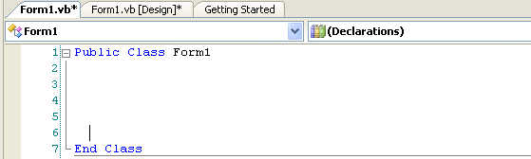
Variable declarations start here

We will put variable declaration statements directly beneath the header line (Public Class Form1) and before any event procedures. In this particular window, we would start at Line 2. This location in the code window is known as the general declarations area and any variables declared here can be used (the value can be accessed and/or changed) in any of the project’s event procedures.

A little secret: depending on the settings of your installation of Visual Basic Express, it may not really be necessary to declare every variable you want to use, even though it’s a very good idea. Most likely, your installation is set up to require variable declaration, but let’s check. Follow these steps:

- Make sure Visual Basic Express is running.
- Start a new project, if one isn’t already loaded.
- Go to the Solution Explorer window. Right-click the project name and select Properties. Make sure you right-click the project name and not the solution name.

This project properties window should appear. Click Compile on the left side of the window:

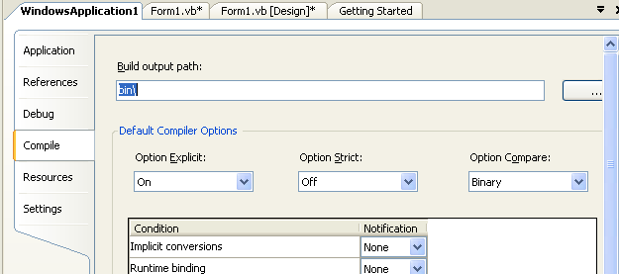
If the word On does not appear next to the Option Explicit (meaning we need to explicitly declare all variables) choice, change it so it does, then close the window (click the X in the upper right corner). This change will be in effect for all projects built in Visual Basic Express. So, for every project you build, all variables must be declared. We will see how this helps in making our programming tasks easier as we build the project in this class.

Try typing some variable declarations in the code window. Here are some examples to try:

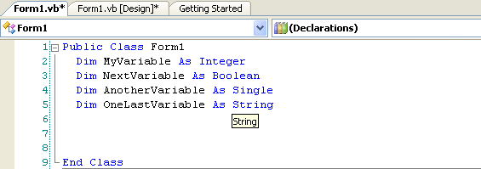

Notice that as soon as you type the keyword As, the Intellisense feature pops up a list of acceptable variable types to choose from, saving typing. Notice how many types there are!

Arithmetic Operators

One thing computer programs are very good at is doing arithmetic. They can add, subtract, multiply, and divide numbers very quickly. We need to know how to make our Visual Basic Express projects do arithmetic. There are seven arithmetic operators in the BASIC language.

Addition is done using the plus (+) sign and subtraction is done using the minus (-) sign. Simple examples are:

Operation Example Result
Addition 7 + 2 9
Addition 3 + 8 11
Subtraction 6 - 4 2
Subtraction 11 - 7 4

Multiplication is done using the asterisk (*) and division is done using the slash (/). Simple examples are:

Operation Example Result
Multiplication 8 * 4 32
Multiplication 2 * 12 24
Division 12 / 2 6
Division 42 / 6 7

I’m sure you’ve done addition, subtraction, multiplication, and division before and understand how each operation works. The three other BASIC arithmetic operators may not familiar to you, though.
The next operator is the exponentiation operator, represented by a caret symbol (^) or sometimes called a ‘hat.’ The caret is typed when you hold down <Shift> while typing a 6. Exponentiation is used when you want to multiply a number times itself a certain number of times. You’ve probably ‘squared’ numbers before, or multiplied a number times itself - this is an example of an exponentiation. If you have an integer variable named A and one named B, A ^ B means you would multiply A times itself B times. Some examples:

Example Result
5 ^ 2 25
2 ^ 4 16
3 ^ 3 27

The other arithmetic operators are concerned with dividing integer numbers. The integer division operator is a backslash character (\). This works just like normal division except only integer (whole number) answers are possible - any remainder from the division is ignored. Conversely, the modulus operator, represented by the BASIC keyword Mod, divides two integer numbers, ignores the main part of the answer, and just gives you the remainder! It may not be obvious now, but the modulus operator is used a lot in computer programming. Examples of both of these operators are:

Operation Example Division Result Operation Result
Integer division 7 \ 2 3 Remainder 1 3
Integer division 23 \ 10 2 Remainder 3 2
Integer division 18 \ 3 6 Remainder 0 6
Modulus 7 Mod 4 1 Remainder 3 3
Modulus 14 Mod 3 4 Remainder 2 2
Modulus 25 Mod 5 5 Remainder 0 0

Study these examples so you understand how integer division works in BASIC.

What happens if an assignment statement contains more than one arithmetic operator? Does it make any difference? Look at this example:

7 + 3 * 4

What’s the answer? Well, it depends. If you work left to right and add 7 and 3 first, then multiply by 4, the answer is 40. If you multiply 3 times 4 first, then add 7, the answer is 19. Confusing? Well, yes. But, BASIC takes away the possibility of such confusion by having rules of precedence. This means there is a specific order in which arithmetic operations will be performed. That order is:

- Exponentiation (^)
- Multiplication (*) and division (/)
- Integer division (\)
- Modulus (Mod)
- Addition (+) and subtraction (-)

So, in an assignment statement, all exponentiations are done first, then multiplications and divisions, then integer divisions, then modulus operations, and lastly, additions and subtractions. In our example (7 + 3 * 4), we see the multiplication will be done before the addition, so the answer provided by BASIC would be 19.

If two operators have the same precedence level, for example, multiplication and division, the operations are done left to right in the assignment statement. For example:

24 / 2 * 3

The division (24 / 2) is done first yielding a 12, then the multiplication (12 * 3), so the answer is 36. But what if we want to do the multiplication before the division - can that be done? Yes - using the BASIC grouping operators - parentheses (). By using parentheses in an assignment statement, you force operations within the parentheses to be done first. So, if we rewrite our example as:

24 / (2 * 3)

the multiplication (2 * 3) will be done first yielding 6, then the division (24 / 6), yielding the desired result of 4. You can use as many parentheses as you want, but make sure they are always in pairs - every left parenthesis needs a right parenthesis. If you type an assignment statement in the Visual Basic Express code window with unmatched parentheses (a syntax error), the end of the statement will be ‘squiggled’ indicating an error. If you nest parentheses, that is have one set inside another, evaluation will start with the innermost set of parentheses and move outward. For example, look at:

((2 + 4) * 6) + 7

The addition of 2 and 4 is done first, yielding a 6, which is multiplied by 6, yielding 36. This result is then added to 7, with the final answer being 43. You might also want to use parentheses even if they don’t change precedence. Many times, they are used just to clarify what is going on in an assignment statement.

As you improve your programming skills, make sure you know how each of the arithmetic operators work, what the precedence order is, and how to use parentheses. Always double-check your assignment statements to make sure they are providing the results you want.

Val and Str Functions

A common task in any Visual Basic Express project is to take numbers input by the user, do some arithmetic operations on those numbers, and output the results of those operations. How do you do this? With the Visual Basic Express knowledge you have up to this point, you probably see you could use text box controls to allow the user to input numbers. Then you could use the arithmetic operators to do the math and label controls to display the results of the math. And, that’s just what you would do. But, there are two problems:

Problem One: Arithmetic operators can only work with numbers (for example, integer variables and integer properties), but the value provided by a text box control (the Text property) is a string. You can’t add and multiply string type variables and properties!

Problem Two: The result of arithmetic operations is a number. But the Text property of a label control (where we might want to display these results) is a string type. You can’t store numerical data in a string quantity!

We need solutions to these two problems. The solutions lie in the BASIC built-in functions. We need ways to convert strings to numbers and, conversely, numbers to strings. With this ability, we could take the Text property from a text box, convert it to a number, do some math, and convert that numerical result to a string that could be used as a Text property in a label box. This is a very common task in BASIC and BASIC has a large set of functions that help us do such common tasks. The two functions that will solve our current problems are the Val function and the Str function. We will look at these in a bit, but first let’s define just what a function is.

A BASIC function is a built-in procedure that, given some information by us, computes some desired value. The format for using a function is:

FunctionValue = FunctionName(ArgumentList)

FunctionName is the name of the function and ArgumentList is a list of values (separated by commas) provided to the function so it can do its work. In this assignment statement, FunctionName uses the values in ArgumentList to compute a result and assign that result to the variable we have named FunctionValue. We must insure the variable FunctionValue has the same type as the value computed by FunctionName. How do we know what BASIC functions exist, what type of information they provide, and what type of arguments they require? Use the Visual Basic Express on-line help system and search for Functions. You’ll see that there are lots of them. We’ll cover some of them in this class, but you’ll have to do a little studying on your own to learn about most of them. Now, let’s look at our first two BASIC functions: Val and Str. Maybe look them up in the on-line help system to do a little ‘get-ahead’ reading.

The BASIC Val function will convert a string type variable (or control property) to a numerical value. The format for using this function is:

YourNumber = Val(YourString)

The Val function takes the YourString variable (remember this is called an argument of the function), converts it to a numerical value, and assigns it to the variable YourNumber. We could then use YourNumber in any arithmetic statement. Recall strings must be enclosed in quotes. An example using Val:

YourNumber = Val(“23”)

Following this assignment statement, the variable YourNumber has a numerical value of 23.

The BASIC Str function will convert a numerical variable (or control property) to a string. The format for using this function is:

YourString = Str(YourNumber)

The Str function takes the YourNumber argument, converts it to a string type value, and assigns it to the variable named YourString. In the example:

YourString = Str(23)

the variable YourString has a string value of “23”.

You should be comfortable with converting numbers to strings and strings to numbers using the Val and Str functions. As mentioned, this is one of the more common tasks you will use when developing Visual Basic Express projects.

String Concatenation

A confession - in the above discussion, you were told a little lie. The statement was made that you couldn’t add and multiply strings. Well, you can’t multiply them, but you can do something similar to addition. Many times in Visual Basic Express projects, you want to take a string variable from one place and ‘tack it on the end’ of another string. The fancy word for this is string concatenation. The concatenation operator is an ampersand (&) and it is easy to use. As an example:

NewString = “Visual ” & “Basic Express”

After this statement, the string variable NewString will have the value “Visual Basic Express”. In some books about BASIC and Visual Basic Express, you may also see the plus sign (+) used as a concatenation operator and it will work. We will only use the ampersand here to distinguish string concatenation from the arithmetic operation of addition.

As you’ve seen, string variables are a big part of Visual Basic Express. As you develop as a programmer, you need to become comfortable with strings and working with them. You’re now ready to attack a new project.

Project - Savings Account

Project Design

In this project, we will build a savings account calculator. We will input how much money we can put into an account each week and the number of weeks we put money in the account. The project will then compute how much we saved. We will use text boxes as both the input controls and for output information. A button will be used to do the computation. This project is saved as Savings in the course projects folder (\BeginVBE\BVBE Projects).

Place Controls on Form

Start a new project in Visual Basic Express. Place three text box controls, three label controls, and two buttons on the form. Your form should resemble this:

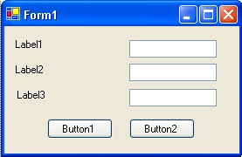
TextBox1
TextBox2
TextBox3

Again, try using copy and paste for the similar controls.

Set Control Properties

Set the control properties using the properties window (remember, controls are listed by their default name):

Form1 Form:
Property Name Property Value
Text Savings Account
FormBorderStyle Fixed Single
StartPosition CenterScreen

Label1 Label:
Property Name Property Value
Name lblDepositHeading
Text Weekly Deposit
Font Arial
Font Size 10

Label2 Label:
Property Name Property Value
Name lblWeeksHeading
Text Number of Weeks
Font Arial
Font Size 10

Label3 Label:
Property Name Property Value
Name lblTotalHeading
Text Total Savings
Font Arial
Font Size 10

TextBox1 Text Box:
Property Name Property Value
Name txtDeposit
TextAlign Right
Font Arial
Font Size 10

TextBox2 Text Box:
Property Name Property Value
Name txtWeeks
TextAlign Right
Font Arial
Font Size 10

TextBox3 Text Box:
Property Name Property Value
Name txtTotal
TextAlign Right
Font Arial
Font Size 10
ReadOnly True
BackColor White
TabStop False

(Note the background color changes when setting ReadOnly to True. Hence, we set BackColor to White to match the appearance of the other two text boxes.)

Button1 Button:
Property Name Property Value
Name btnCompute
Text Compute

Button2 Button:
Property Name Property Value
Name btnExit
Text Exit
Note this is the first time you have been asked to change Font properties. Review the procedure for doing this (Class 4 under Button Control), if necessary. Change any other properties, like colors, if you would like. When you are done, your form should resemble this:

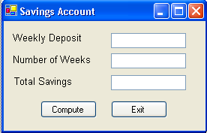
lblDepositHeading
lblWeeksHeading
lblTotalHeading
btnCompute
txtDeposit
txtWeeks
txtTotal
btnExit

Write Event Procedures

In this project, the user types an amount in the Weekly Deposit text box. Then, the user types a value in the Number of Weeks text box. Following this, the user clicks the Compute button. The project determines the total amount in the savings account and displays it in the lower text box control. Hence, the primary event in this project is the Click event on the Compute button. The only other event is the Click event on the Exit button. It’s always good to have an obvious way for the user to exit a project.

We need three variables in this project (we will use Integer types), one to hold the weekly deposit amount (Deposit), one to store the number of weeks (Weeks), and one to store the total savings (Total). Open the code window and find the general declarations. Declare these three variables:

Dim Deposit As Integer
Dim Weeks As Integer
Dim Total As Integer

The code window should appear as:

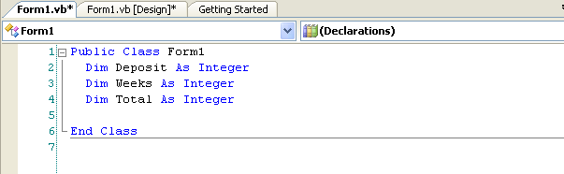

The event procedures will start after Line 4.

The btnCompute_Click event implements the following steps:

- Convert input deposit value (txtDeposit.Text) to a number and store it in the variable Deposit.
- Convert input number of weeks (txtWeeks.Text) to a number and store it in the variable Weeks.
- Multiply Deposit times Weeks and store the result in the variable Total.
- Convert the numerical value Total to a string, concatenate it with a dollar sign ($), and store it in Text property of txtTotal.

In code, these steps are:

Private Sub btnCompute_Click(ByVal sender As System.Object, ByVal e As System.EventArgs) Handles btnCompute.Click
'Get deposit amount
Deposit = Val(txtDeposit.Text)
'Get number of weeks
Weeks = Val(txtWeeks.Text)
'Compute total savings
Total = Deposit * Weeks
'Display Total
txtTotal.Text = "$" & Str(Total)
End Sub

Notice how is easy it is to translate the listed steps to actual BASIC code. It is just paying attention to details. In particular, look at the use of Str and Val for string-number conversion.

The btnExit_Click procedure is simply one line of code that stops the program by closing the form:

Private Sub btnExit_Click(ByVal sender As System.Object, ByVal e As System.EventArgs) Handles btnExit.Click
Me.Close()
End Sub

Save your project by clicking the Save All button.

Run the Project

Run the project. Click in the Weekly Deposit text box and type some value. Do the same with Number of Weeks. Click the Compute button. Your answer should appear in the Total text box control. Make sure the answer is correct. Remember, a big step in project design is making sure your project works correctly! If you say you want to save 10 dollars a week for 10 weeks and your computer project says you will have a million dollars by that time, you should know something is wrong somewhere! Click Exit to make sure it works. Save your project if you changed anything. Here’s a run I made:

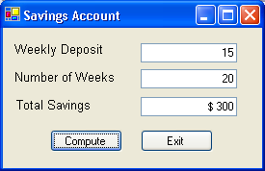

This project may not seem all that complicated. And it isn’t. After all, we only multiplied two numbers together. But, the project demonstrates steps that are used in every Visual Basic Express project. Valuable experience has been gained in recognizing how to read input values, convert them to the proper type, do the math to obtain desired results, and output those results to the user.

Other Things to Try

Most savings accounts yield interest, that is the bank actually pays you for letting them use your money. This savings account project has ignored interest. But, it is fairly easy to make the needed modifications to account for interest - the math is just a little more complicated. We will give you the steps, but not show you how, to change your project. Give it a try if you’d like:

- Define a variable Interest to store the yearly savings interest rate. Interest rates are decimal numbers, so use the Single type for this variable (it’s the first time we’ve used decimals!).
- Add another text box to allow the user to input this interest rate. Name it txtInterest.
- Add a label control to identify the new text box (set the Text to Interest Rate).
- Modify the code to use Interest in computing Total. Interest is found using:

Interest = Val(txtInterest.Text)

Then, Total (get ready - it’s messy looking) is computed using:

Total = 5200 * (Deposit * ((1 + Interest / 5200) ^ Weeks - 1) / Interest)

Make sure you type this all on one line - the word processor has made it look like it is on two. As we said, this is a pretty messy expression, but it’s good practice in using parentheses and some other arithmetic operators. The number ‘5200’ is used here to convert the interest from a yearly value to a weekly value.

Now, run the modified project. Type in values for Deposit, Weeks, and Interest. Click Compute button. Make sure you get reasonable answers. (As a check, if you use a Deposit value of 10, a Weeks value of 20, and an Interest value of 6.5, the Total answer should be $202 - note you’d have $200 without interest, so this makes sense). The project automatically converts Total to an integer (since it is declared that type) even though there is probably a decimal (some cents) involved in the answer. Save your project.

Before leaving this project, let’s look at one more thing. Remember we said that, even though we don’t have to, we will declare every variable we use in our projects? Let’s demonstrate a good reason why we do this. Open the Savings Account project, if it’s not already opened. This example will work whether or not the interest computation has been programmed. Go to the btnCompute_Click event procedure and purposely misspell the variable Deposit. For example, change the line:

Deposit = Val(txtDeposit.Text)

to:

Depsit = Val(txtDeposit.Text)

Run the project. You receive a ‘build error.’ Don’t continue and go to the Error List window, where you will see a message saying “Name Depsit is not declared” and be given a line number for the offending line. Go to that line in the code window (double-click the error message) and the misspelled variable Depsit should be highlighted in the code window. Visual Basic Express is telling you there is no declared variable with that name. It is pointing out your misspelling. It has shown you your mistake. Do not correct the error.

What happens in this case if variable declaration is not required? Go to the Project Explorer window, right-click the project name (don’t right-click the solution name) and select Properties. In the Savings Project Properties window that appears, click the Compile tab. Turn Off the Option Explicit choice. You have now removed the requirement that we declare all variables in your project. Close the properties window.

Run the project now (it should run without build errors). Type in some numbers. Click Compute. Enter some values. Notice the program seems to run OK, but the answer is wrong. Visual Basic Express thinks Depsit and Deposit are variables in your project. Since Deposit is never evaluated, it is assumed to be zero. So, no matter what values you input, the computed Total will always be zero. You have a logic error in your code. You know something is wrong, but you would have to look into your code to figure out what. Visual Basic Express gives you no help in identifying your mistake in this case. With required variable declarations, the variable error was obvious. Hence, by declaring all of our variables, we make the process of writing error-free event procedures a little easier. Stop the project. Restore the Option Explicit value to On by reversing the earlier steps for project properties. Rerun the project to make sure it is working properly again.

Summary

In this class, you have learned a lot of new material. You learned about the label and text box controls. You learned about variables: naming them, their types and how to declare them properly. And, you learned functions that allow you to change from string variables to numbers and from number to strings. You learned how to do arithmetic in BASIC. Like we said, a lot of new material. In subsequent classes, we will stress new controls and new BASIC statements more than new features about the Visual Basic Express environment. You should be fairly comfortable in that environment, by now.

